|  |
| --- |
| Operating  systems  ECE 001 |
| Fady Sabry Kamel Student ID : 2166120200101101  B.N : 564  Date : June 7, 2021  GitHub-Link: https://github.com/fady-sabry11/html-project-repo |



**كلية الهندسة بشبرا | جامعة بنها**

Project brief

operating systems

An **operating system** is the **most important software** that runs on a computer. It manages the computer's **memory** and **processes**, as well as

all its **software** and **hardware**. It also allows you to **communicate** with the computer without knowing how to speak the computer's language. **Without an operating system, a computer is useless**.

So, in this project, we will be discussing the importance of operating systems. In addition, there will be an overview of the most well-known operating systems in the world for both desktop and mobile devices.

Screenshots

Webpages

Figure 1

Figure 2

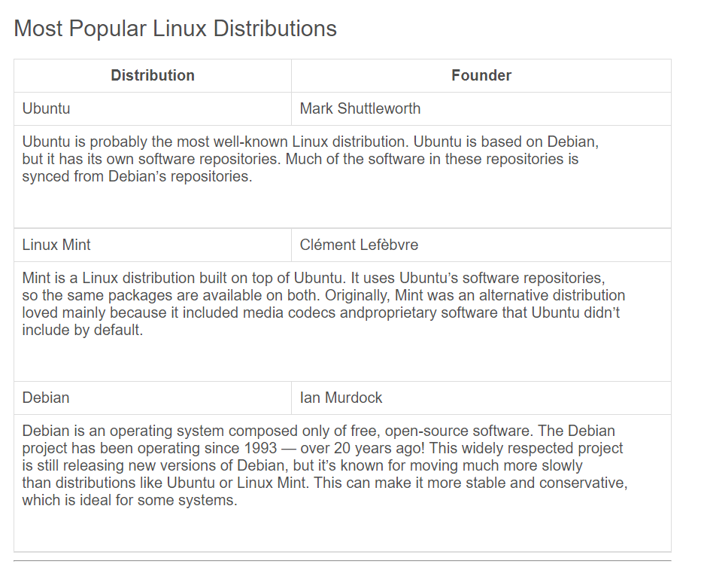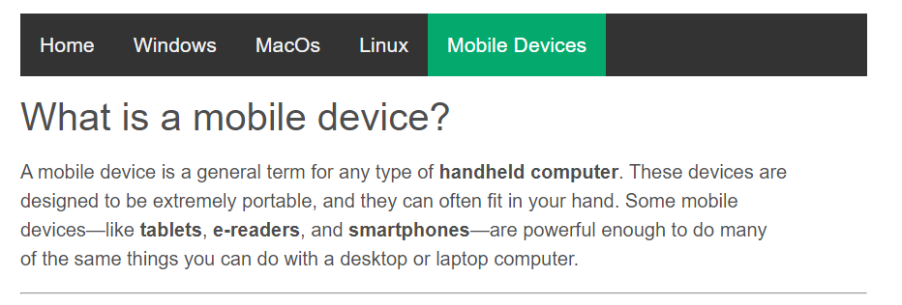

Figure 4

Figure 5

Figure 3

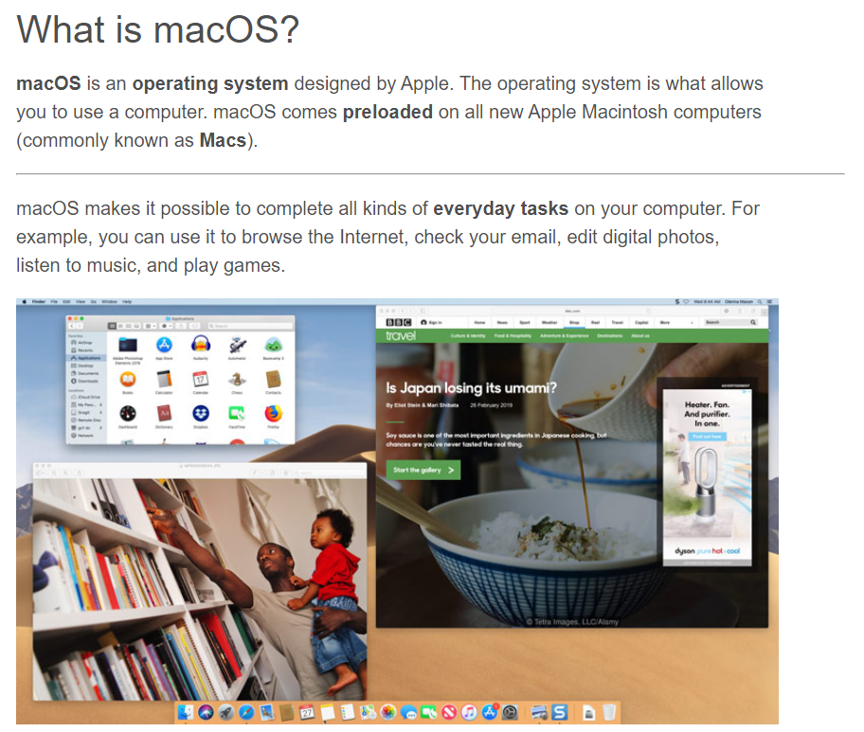

Figure 6

Figure 7

Source Code

Figure 8

Figure 9

Figure 10

Figure 11

Figure 12

Citation

Brent, E. (2020, August 4). *macOS Basics: All About macOS*. GCFGlobal.org. https://edu.gcfglobal.org/en/macosbasics/all-about-macos/1/.

Dean, E. (2020, March 11). *Computer Basics: Mobile Devices*. GCFGlobal.org. https://edu.gcfglobal.org/en/computerbasics/mobile-devices/1/.

Hoffman, C. (2017, July 4). *10 of the Most Popular Linux Distributions Compared*. How. https://www.howtogeek.com/191207/10-of-the-most-popular-linux-distributions-compared/.

Krishna, gohar. (2012, November 11). *Introduction to Linux Operating System (OS): What is Linux?* Guru99. https://www.guru99.com/introduction-linux.html.

Matt, K. (2020, August 4). *Windows Basics: All About Windows*. GCFGlobal.org. https://edu.gcfglobal.org/en/windowsbasics/all-about-windows/1/.

Shane, E. (2020, August 7). *Computer Basics: Understanding Operating Systems*. GCFGlobal.org. https://edu.gcfglobal.org/en/computerbasics/understanding-operating-systems/1/.